Non-Studio Upstairs Artist Date of submission:

Section 1: Artist Information

Name
Address
Telephone/s
Email
Website/blog if applicable

Artist Biography / Resume - please keep this brief, a short paragraph is enough

Payment Details (Add details below for your chosen payment method in BLOCK CAPITALS)
Bank Account Details for BACS
Name on Bank Account:
Account Number: |  | Sort Code:

Proceeds from artwork sales might be considered taxable income and income declaration is a responsibility of the artist. Guidance is available from the following organisations:HMRC helpline - 0300 200 3310; Citizens Advice; Tax Help for Older People; Taxaid.org.uk

Section 2: Artwork Information
Please make a copy of this section for each piece of artwork you are submitting

Title 1:
Medium: |  | Surface:
Dimensions (cm) | Height: | Width: | Depth:
Sale price | £ | Framed price? £ | Unframed price? £
Optional percentage of sale donated to SU (not commission) | 50% | 70% | 100%

Artist statement / About this artwork:

Title 2:
Medium: |  | Surface:
Dimensions (cm) | Height: | Width: | Depth:
Sale price | £ | Framed price? £ | Unframed price? £
Optional percentage of sale donated to SU (not commission) | 50% | 70% | 100%

Artist statement / About this artwork:

OFFICE USE | Product code: Date artwork received ___/___/___  Location :
Listing start date | ___/___/___
Listing end date | ___/___/___

CHECKLIST
Please ensure you have done the following:

- Completed all sections of the form
- Read and accepted the Artist Submission Terms & Conditions
- Photographed the artwork in high resolution and saved the image files (jpeg) with your name as follows: FIRSTNAME_LASTNAME_TITLE
- Emailed of the images of the work to submissions@studioupstairs.org.uk

TERMS & CONDITIONS

- Studio Upstairs (SU) provides a platform for artists at all stages of their career to promote and sell artworks through the gallery or online. SU retains its discretion to refuse artwork that is inappropriate.

- Artists must complete an Artwork Submissions form.

- The proceeds from donated work will go towards supporting the core work of the charity. SU reserves the right on whether to accept any donation.

- The commission charged to the artist covers the marketing, administration and handling of the submitted work.

- All artwork must be original, not a copy of someone else’s work.

- SU will accept up to 4 images per artist for online listings

- Photography: when taking photographs of your artwork, use a white/ neutral background with good even light, ensure there are no obstructions or glare within the image.
Not acceptable  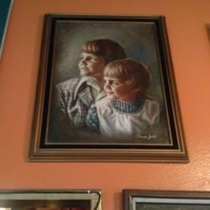  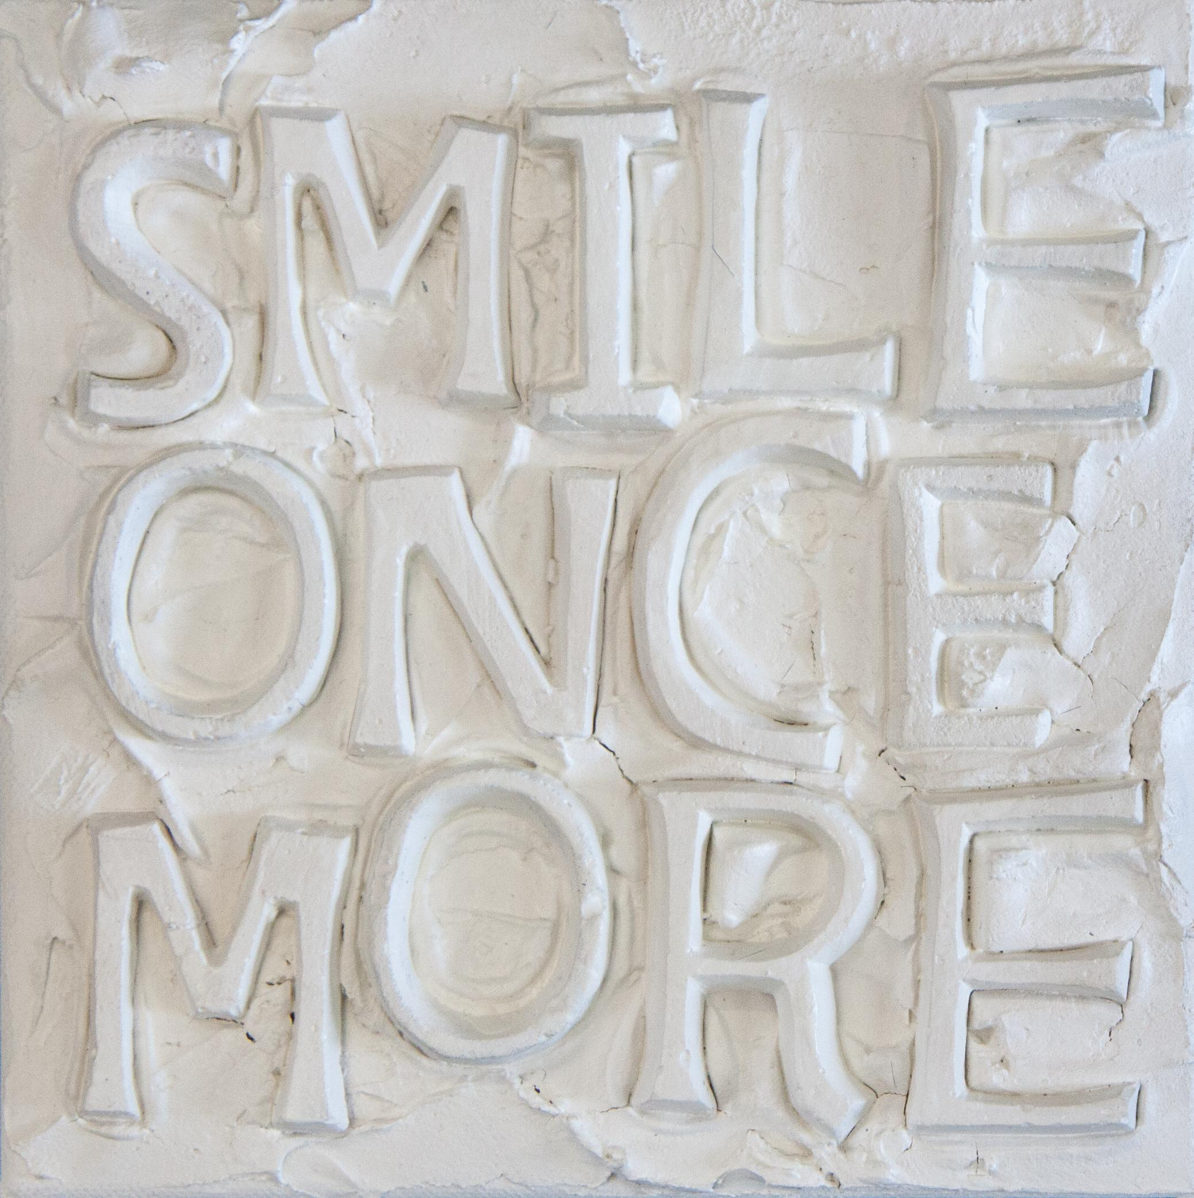  At an angle, low light, dark background, other items in image | Acceptable  Full image, no background, balanced light, clear detail

- Works will be listed on the website for 3 months or until the work is sold - whichever is first. If work is not sold after a period of 3 months, artists may be invited to re-submit new images.

- Artwork that is donated or stored at SU sites requires prior agreement - these artworks must be delivered to the Studio prior to being advertised on the website.

- Payments:
  - Payment from the buyer will be made to Studio Upstairs.
  - The payment to the artist will be made by bank transfer, on the second Tuesday of the month. This payment will be calculated based on the final price of the artwork sold minus commission and with consideration of any delivery charges.

- Arranging delivery to the buyer if/when sold.
  - The cost of packaging and delivery will vary according to destination/weight and will be charged to the buyer by SU when the work is with SU.
  - When artwork is with the artist, the artist must arrange delivery to the buyer within 5 working days of the sale. The artist will receive back the full cost of delivery when the payment is made on the second Tuesday of the month.

- Every reasonable precaution will be taken in handling the work. Work should not be so fragile that shipment would be potentially harmful to the work or those handling it.

- SU will not be responsible for any loss, theft or damage. You are advised to arrange your own insurance.

- If any submitted artwork is sold elsewhere at any point during the 6 month listing period, it is the duty of the artist to inform Studio Upstairs immediately so that it can be removed from the website.

By completing and emailing the completed form you are accepting the Terms and Conditions outlined above.

Name:
Date:

