Studio Application Form 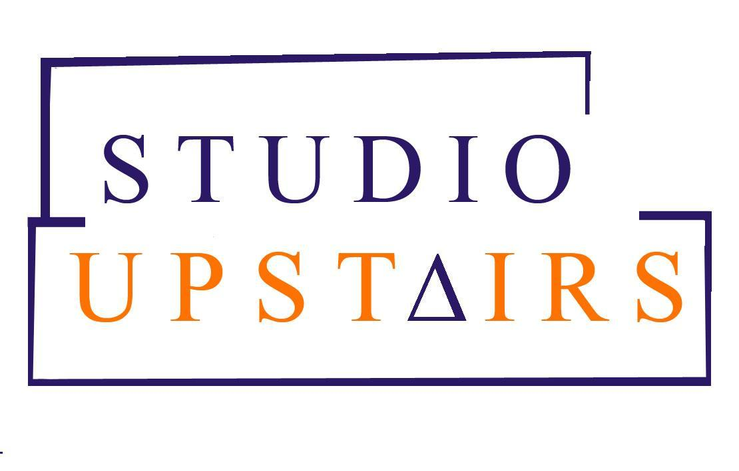
Please return when completed to opportunities@studioupstairs.org.uk

Role Applied for:
Location: Bristol/North London/ South London (please delete as appropriate)

Personal Details
Title: Ms/ Mrs/ Mr
Name:
Surname:
Address:
Postcode:
Email:
Phone:
Mobile:

Work Experience (starting with most current roles, add additional rows if needed)

Role Title & Main Responsibilities | Employer | Start Date | End Date | Reason for Leaving

Education, Qualifications and Training
Course of Study | Place of Study | Level/ Mark/ Qualification | Dates (from – to)
Where a specific qualification is an essential requirement you will be required to produce original certificates if you are offered the post.

Additional Information

Are you required to have a work permit? | Yes/No
If ‘yes’, do you have one? | Yes/No
On how many days per week are you currently available for work? | 1/2/3/4/5
On which weekdays are you available for work? | Mon/Tue/Wed/Thur/Fri/Sat/Sun

What period of notice is required for current job
If this would not be your only employment,
please state the other employer and
the specific time commitment with them over the week
Do you hold a current DBS certificate? | Yes/No
If No, please tick that you are willing to undertake DBS check
Are you HCPC registered? | Yes/No
Do you hold a current professional indemnity insurance? | Yes/No

Personal Statement
Please read outline why you are interested in the role, as well as your relevant experience and evidence of achievements in no more than 2 A4 pages

REFERENCES

Please give the name and addresses of two referees. One must be your current or most recent employer. References from personal friends or relatives are not accepted.
Referee 1  Name:  Job title:  Position held in relation to you:  Organisation:  Telephone:  Email:  Address: | Referee 2  Name:  Job title:  Position held in relation to you:  Organisation:  Telephone:  Email:  Address:

DECLARATION

By submitting this form I confirm that the details given in this form are correct and understand that any false declaration may result in disciplinary action being taken, which could result in my dismissal from post. I hereby explicitly consent to Studio Upstairs holding my personal details within a manual or electronic filing system in relation to the Data Protection Act, 1998.
…...................................................................................................................................................

Equal Opportunities Monitoring Information

The following information does not form part of your application - it is used for statistical and monitoring purposes in agreement with the Studio Upstairs Equal Opportunities and Diversity Policy. Selection for roles with the organisation is based on meeting the criteria of the role as outlined in the role/job description.

Role Applied for:

How did you come across this opportunity? | Mark with X or if relevant specify detail
Search engine (please specify)
Studio Upstairs leaflet
Other Printed media (please specify)
Studio Upstairs website
Other website (please specify)
Job centre
Friend/relative/colleague
Employment agency (please specify)
Other (please specify)

Gender (delete as appropriate) | Male/ Female/Transgender | Date of birth

ETHNICITY
Please indicate how you prefer to describe your ethnic origin.
Black British |  | Asian British |  | White British
Black African-Caribbean |  | Bangladeshi |  | White Irish
Black African |  | Indian |  | White Other
Black Other |  | Pakistani |  | Mixed
Chinese |  | Romany |  | Other

DISABILITY
_______________________________________________________________________________

For employment purposes, a disabled person is defined as a person with a physical, sensory or mental impairment which has a substantial and long term adverse effect on his or her ability to carry out normal day-to-day activities.

For employment purposes, are you disabled? (Please delete as appropriate) | YES/NO

Please state the nature of your disability

